Cyber game registration in Magento 2

Our system will allow gaming owner to register their cyber game and publish their gaming room. Guest can buy account(hour) in each cyber room.

Backend menu:

Guest account

Frontend menu(In customer detail page)

Edit the game room.

More detail:

In our system , customer will be known as the manager of cybergame.

Product will be known as the cyber room.

Our customer need to use magento 2 to manager the cyber game rooms in Viet Nam.

Admin can create cyber room in backend(a cyber room is a simple product without qty)

Customer in frontend can be register as a cyber manager. A cyber manager can add(or edit) extra option to each cyber room(product). The extra option contain: address, number pc, food drink price. Extra option will store in **room_extra_option** table.

Player(Guest) who need account to play game, need to buy hour in order to play game. The guest account will store in **gamer_account_list** table.

# 1. Create extension, schema (2 point)

### Create extension: (1 point)

Create your extension name [Magenest]_[Cybergame]

Route name(backend/frontend): cybergame

Table **gamer_account_list**

Table **room_extra_option**

### Create install schema (1 point)

You need to create two table with following option.

gamer_account_list

|  |  |
| --- | --- |
| name | note |
| id | PK |
| product_id | (indexed) |
| account_name | (indexed) |
| password |  |
| hour |  |
| created_at | unix time, default = current time |
| updated_at | unix time, default = current time |

room_extra_option

|  |  |
| --- | --- |
| name | note |
| id | PK |
| product_id | indexed |
| number_pc |  |
| address |  |
| food_price |  |
| drink_price |  |
| created_at | unix time, default = current time |
| updated_at | unix time, default = current time |

add attribute for customer: is_manager.

is_manager should set = 1 when customer checked **I'm a cyber manager** or set = null or zero if not **(Question 3a)**

# 2. Backend (2 point)

### Create **GamerAccountList** Model (1 point)

Model

ResourceModel

Collection

### Create backend Grid (1 points)

The admin want to see the extra option of all cyber room(product)

Create **room_extra_option** grid in backend.

# 3. Create add cyber room info in frontend - customer detail page (3 point)

### Register customer page (1 point)

Add a checkbox: I'm a cyber manager. See image below

If customer register checked **I'm a cyber manager**. He can add(edit) the ***room extra opton*** in **update room info** page in **customer detail**

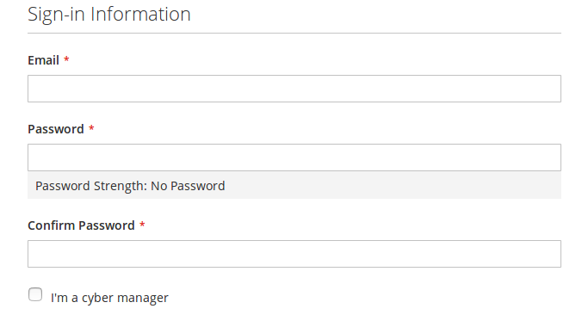

**Customer edit account information** page also have the checkbox I'm a cyber manager with **same logic** as **customer register page.** See image below

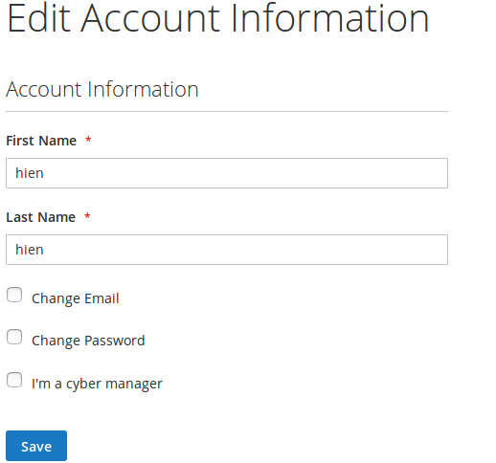

### Update room info (1 point)

Update room info menu should be display in customer detail page. This page should list all the cyber room (product) in the system.

If Customer is a **cyber manager** . He can edit(add) the extra option of cyber room.

If customer is not a **cyber manager.** The edit button should be disabled

The extra option is store in **room_extra_option** table.

See image below.

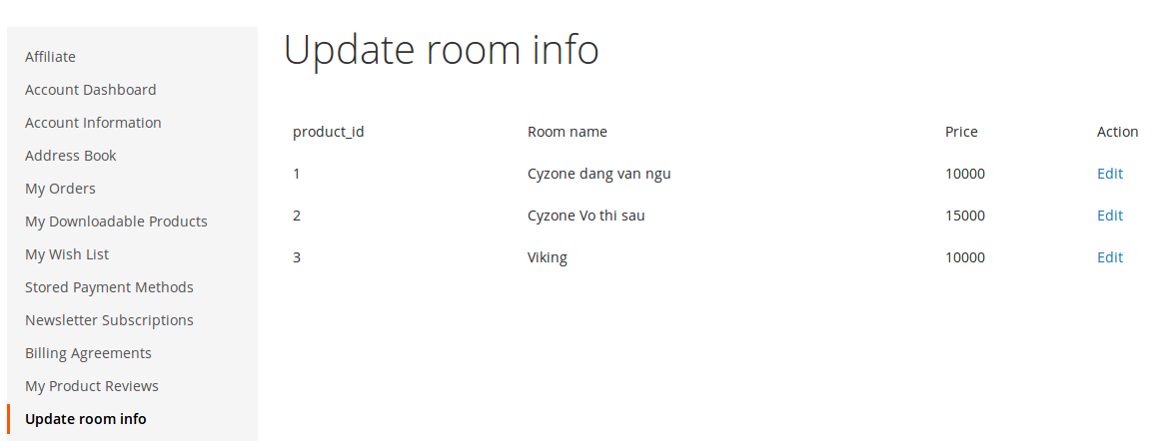

### Edit(add extra option) product (1 point)

Edit extra option page.

The cyber manager need to edit(add) extra option to the cyber room. He can add the number pc, address, food price, drink price.

The cyber room name and Price can not be change(disabled)

**Number pc, price should validate to corresponding type**.

All the field should be prefill if the cyber room already have an extra option before.

See image example below.

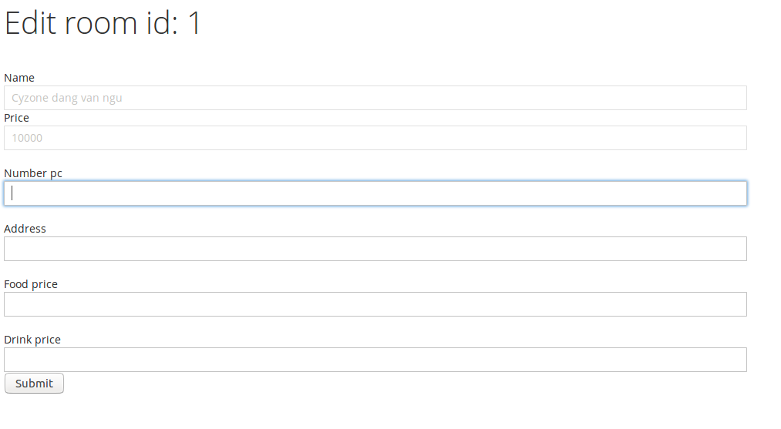

# 4. Add some information in product detail(frontend) (3 points)

### Product detail page (2 point)

Guest will create account or buy more hour in this page.

example : qty = 5 is mean buying 5 hour

Task:

1. Add extra option to this page(number_pc, address, food drink price) if have: **0.5 point**.
2. Add input account name field for guest: **0.5 point**
3. Add some code to change the price dinamic. If the default price is 10000. When guest input 5 in Qty, the price should be change to 50000 immediately. **0.5 point**
4. After guest input account name. We need to check the account was exist or not.

**0.5 point**

**If the account was exist in system.** Show red message: Account was exist in our system. You are buying hour for this acocunt

**If the account was not exist(new account)**. Show blue message: We will create new account for you. Default password = 1. You should change the password after login

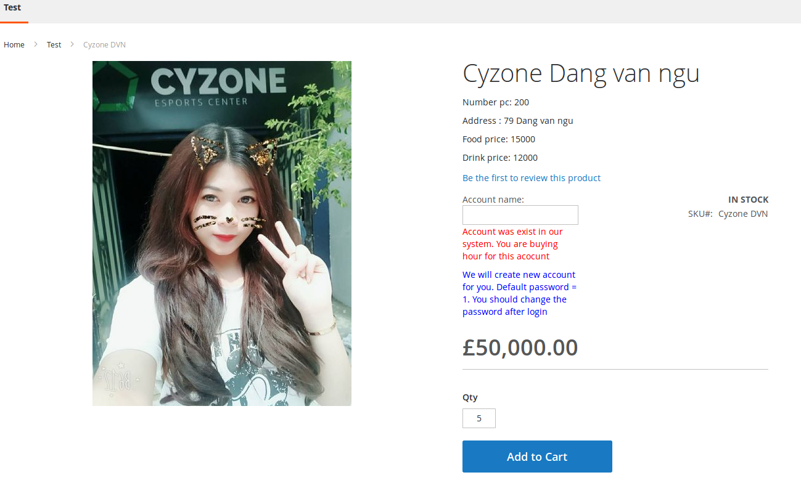

### Checkout success (1 point)

When checkout success: The system will create new account or add hour to exist account.

The guest account is stored in **gamer_account_list** table.

For new account will set password = 1.